# Session 1:

Tasks 1:
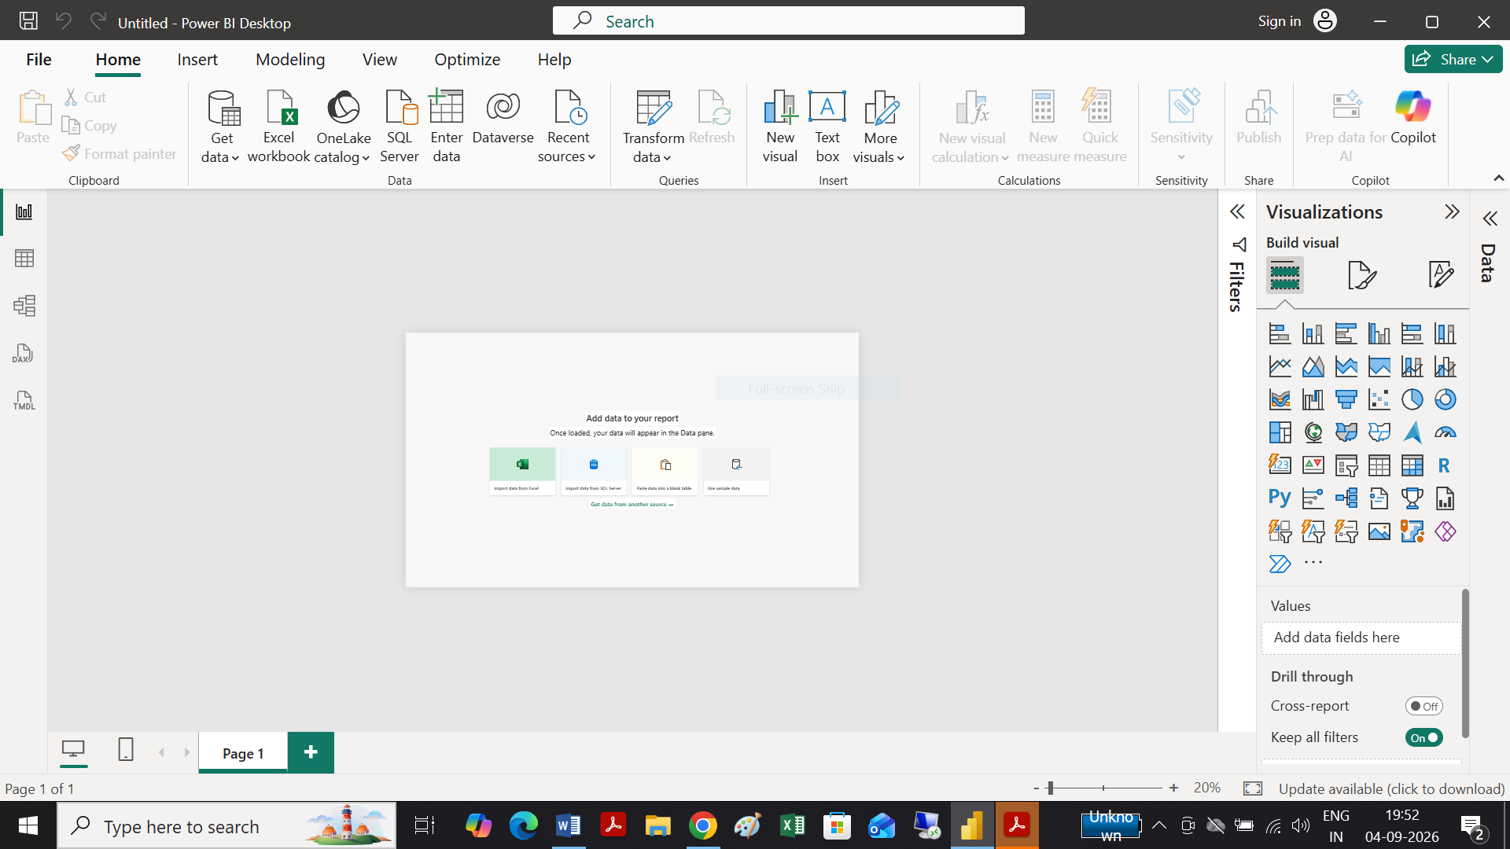

Tasks 2:

Power BI Desktop Interface Components
Component | Short Description
1. Report View | Used to create and design interactive reports and dashboards. You can add charts, tables, cards, slicers, and other visuals here.
2. Data View | Displays the actual data stored in your tables. It allows you to inspect, sort, and work with individual rows and columns of data.
3. Model View | Shows the relationships between different tables in the data model. It is used to create and manage relationships between tables.
4. Fields Pane | Lists all the tables, columns, and measures available in the data model. You can drag these fields onto visuals to build reports.
5. Visualizations Pane | Contains tools for creating and formatting visualizations such as bar charts, pie charts, tables, and graphs. It also provides formatting options for selected visuals.
6. Filters Pane | Allows you to filter the data displayed in a report or visual. Filters can be applied to a specific visual, an entire page, or the whole report
Tasks 3:
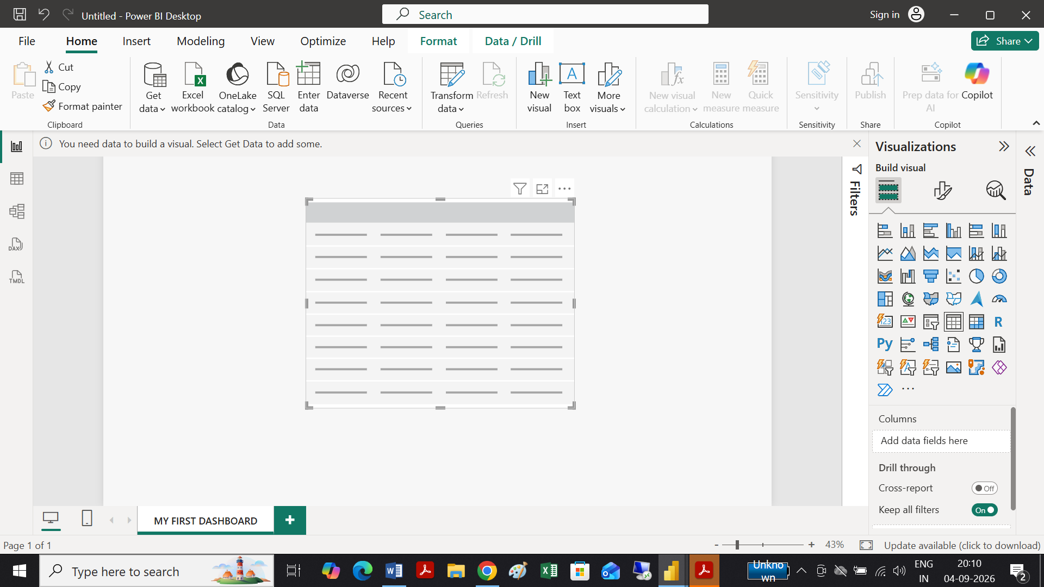

Excel Dashboard | Power BI Dashboard
1. Data & Analysis: Mainly uses worksheets, formulas, PivotTables, and PivotCharts for analysis. | 1. Data & Analysis: Designed for connecting, transforming, and analyzing data from multiple sources using Power Query and DAX.
2. Visualization: Uses charts, tables, slicers, and other Excel objects that are arranged manually on a worksheet. | 2. Visualization: Provides interactive visuals, filters, slicers, and a dedicated Visualizations pane for creating and formatting reports.
3. Workflow & Sharing: Dashboards are generally maintained within Excel workbooks and shared as files. | 3. Workflow & Sharing: Reports can be published to Power BI Service, where dashboards can be shared and viewed interactively across devices.
Tasks 4:
Here are 3 key differences between Excel Dashboards and PowerBI Dashboards:
# Session 2:
Tasks 1:
Report View:
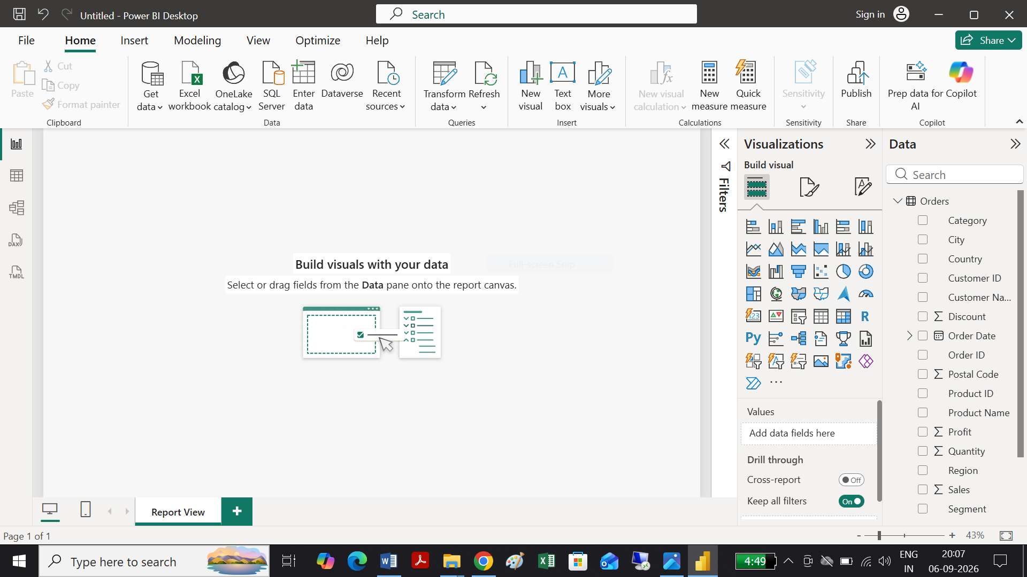

Table View:
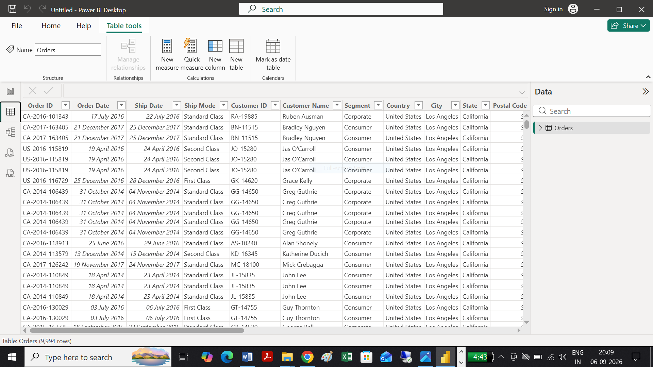

Model View:
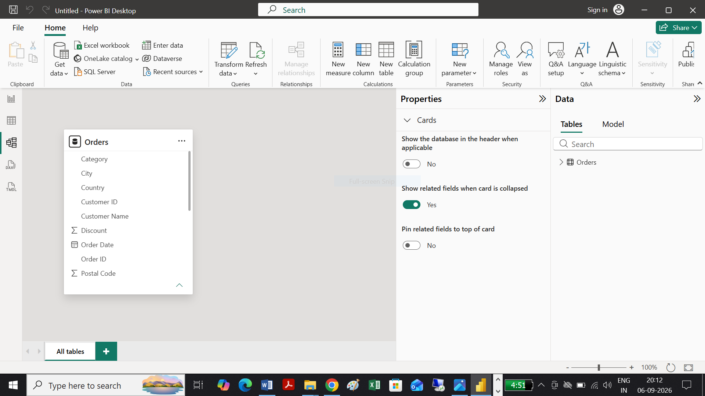

Task 2: BAR CHART & PIE CHART
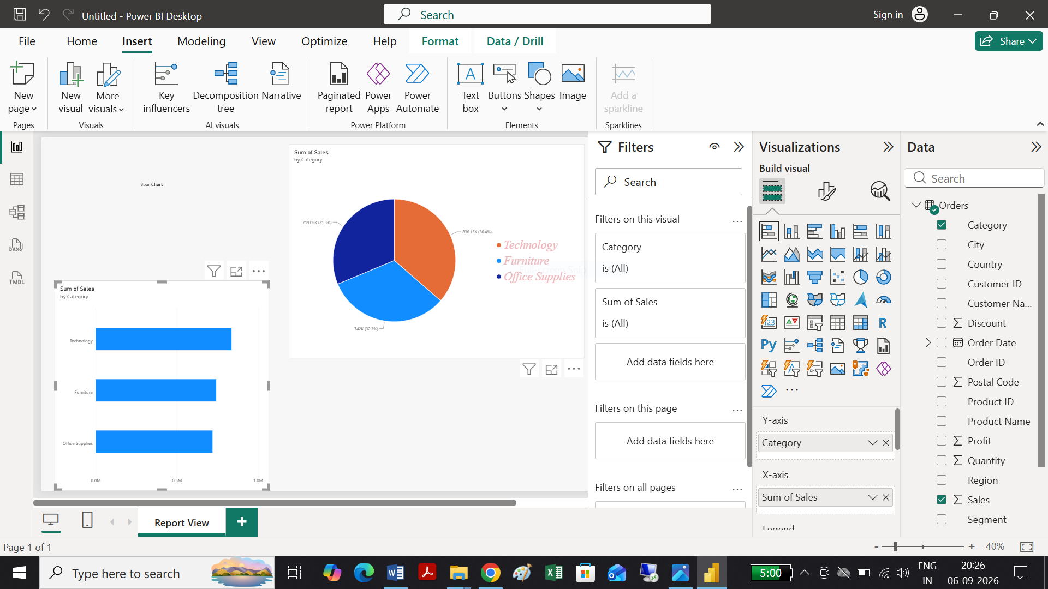
Task 3: Sales Data for Single Category filter Used
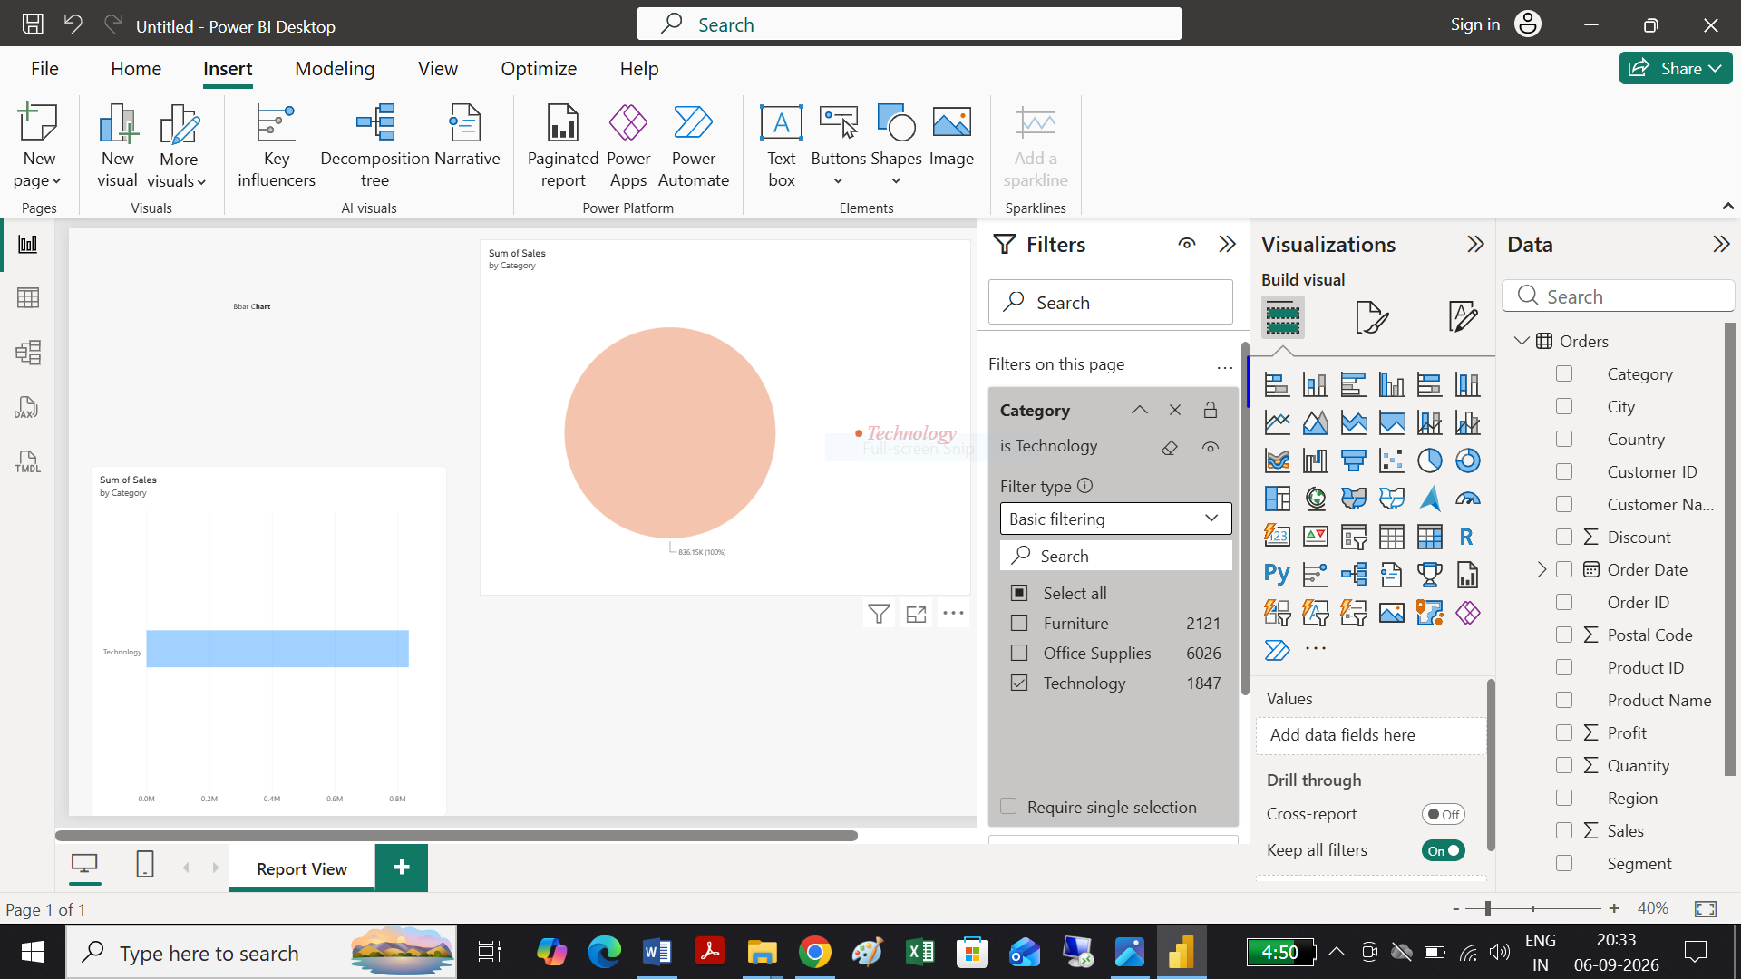

Task 4:
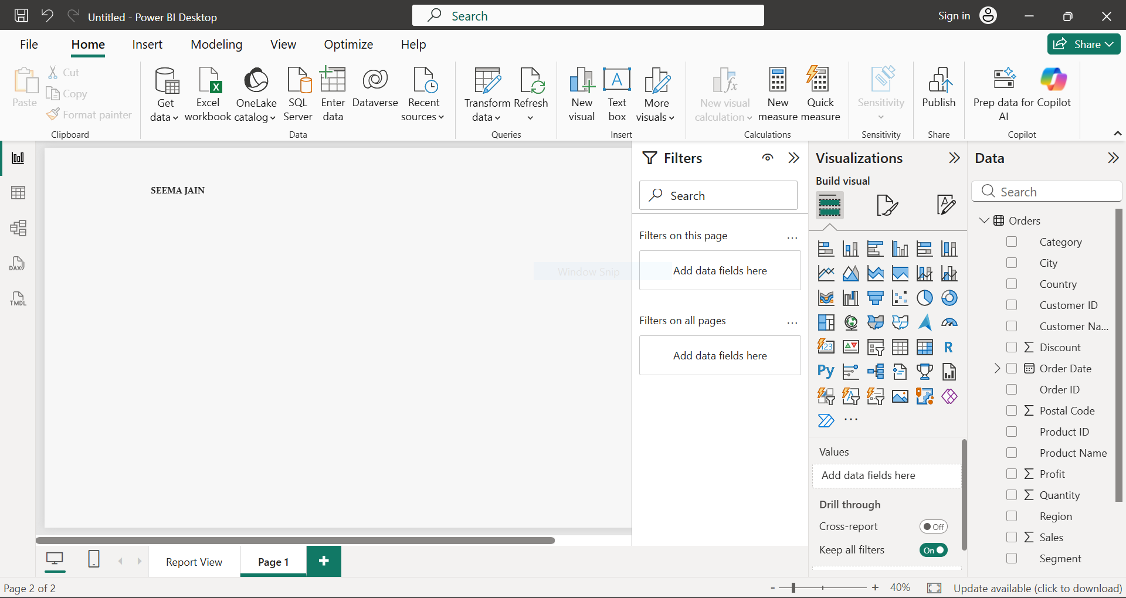

Task 5:

